**Day 2 Lab Assignments**

**Use CSS and CSS3 styles to do the following:**

1. Make a navbar with rounded corners, and use Font awesome, to add some icons to the navbar items.



* 1. Use the icons from Font awesome.
  2. Make the navbar items as list (ul), and inside each list item (li), add a link for each menu item.
  3. Use list style type: none for the list items.
  4. Use display: inline-block for the list items. (Why?).
  5. Handle that when mouse over an item its background color to be changed, and the icon color also to be changed gradually (Use transition).

1. Use Custom font for any paragraph (Search for new fonts, do not use the font given in the lecture)
   1. Search for web fonts libraries (google fonts for example) and use them.
2. Complete Day.1 Assignment.3, as the following:
   1. Use font awesome for icons.
   2. Use server and web fonts for text.
   3. Use border-radius property for skills section.

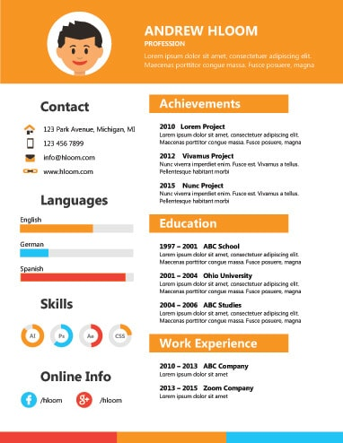

1. Make simple photo gallery, and use transition to make the photos zoom outs with animation on hover (Use transform: scale() with transition).

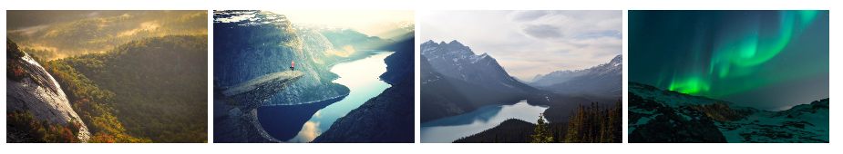

1. Use CSS3 columns on any paragraph.

**<Thank>YOU </Thank>**